CNFBTA
  CNFBTA
    - Monthly Newsletter
    - 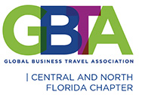April 2021

Introducing our coUntdown to convention 2021

Thank you to all who joined us for our March 11th panel entitled “Travel: From Disruption to Resumption”. In conjunction with the Tampa Bay GBTA Chapter, we tackled subjects such as updated approaches to Duty of Care, “new world” expectations among strategic partners and the current realities of the Travel and Meetings space.
We appreciated your feedback on the valuable content and great dialogue. We also heard you say that the sessions should be shortened so read on for our next virtual discussion, a one hour lunch and learn scheduled for May 13th!


May13th Virtual Lunch and Learn
The Data Story: Returning Travel Demand

Our next virtual panel will take place on May 13th. This one hour lunch and learn session will focus on the story being told by analyzing recent data trends around the return to travel. We’ll have our subject matter experts share insights on the future of travel demand, look at market research on the state of travel resumption derived from recent survey results of Meeting and Convention planners, and talk

about what this means for Central Florida and our Travel industry. Bring your lunch, reserve your spot now and keep an eye out for the link to the webinar!
To register for this free webinar and to view the Bios for our speakers, please see the Calendar on the CNFBTA website https://cnfbta.org/ for MAY and click on May 13th.

Chapter Happenings

Q2 Quarterly Meeting: A Hybrid/Face to Face Opportunity
Safe Travel!

After a year apart, we are all yearning to get together, to come face to face and to network. Shortly we’ll have details to share on our first hybrid/face to face quarterly meeting in one year! Targeted for the 2nd or third week of June, we hope to venture into this new space and focus on what is on everyone’s mind: a return to Safe Travel. With limited in-person capacity, as well as a virtual audience; proper social distancing and CDC guidelines will be followed.
We will be sending an update to all as our speakers are confirmed, details and finalized and our registration site opens. Get ready for an exciting afternoon of dialogue, re-connection and updates on what is happening, and re-opening, in Central Florida.
Reconnect
Rebuild
Reinvigorate

#ReadySafeTravel

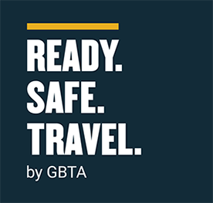

Recent Travel News: March 12th United Airlines CleanPlus Curb-to-Cabin Safety Tour at Orlando International Airport (MCO)

CNFBTA President Shanna Gregg was invited to participate in a recent Curb to Cabin tour offered by United Airlines. This safety tour of UA hangars, aircraft and space at MCO was the first of its kind in more than a year! More than 30 Travel professionals participated, learning firsthand about the procedures and protocols United has implemented to ensure a safe travel experience. It was a great way to reconnect with industry colleagues, hear from company leaders and step back into MCO and a UA lounge. After a year of separation, seeing and interacting with other CNFBTA members was a highlight. Getting to walk through stripped down planes, sit in a pilot’s seat and pose in the infrastructure and housing of an airline engine was certainly a once in a lifetime opportunity!

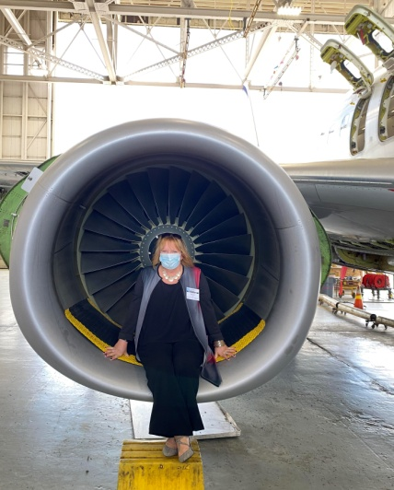



Update: March 25th Volunteer/Community event
Orlando

In our continued commitment to giving back to our communities, CNFBTA took part in a Volunteer Day at Second Harvest Food Bank in Orlando on the afternoon of March 25th.
Along with other corporate and private volunteers, our afternoon group helped process almost 4 tons of food which will help more than 6500 people in Central Florida. We were able to present our 2020 charitable donation of $700 and are excited to partner with Second Harvest in the coming months as we work to give back to our many communities and those in need.
VOLUNTEER. TAKE ACTION.
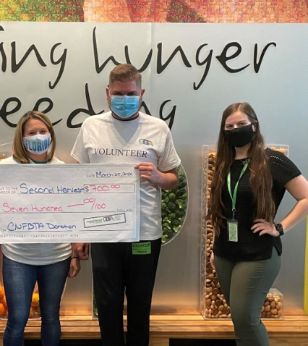
Director, Sponsorship Melissa Petiot and Vice-President, Zachary Warman presenting our CNFBTA 2020 donation

Virtual Food for Thought Tours

If you have one hour, you can learn more about the impact of making donations and volunteerism. You’ll learn more about who is hungry in our community and then take a virtual tour of the food bank to see how we operate.
This tour goes inside an active warehouse and distribution facility as we focus on elevated hunger relief efforts due to the pandemic. If you have questions regarding Food for Thought tours, please contact Maureen Mikel at mmikel@feedhopenow.org or 407-514-1006. A secure Zoom link will be emailed to you prior to the event.


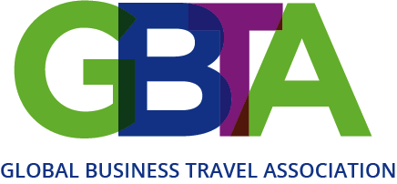

Happenings

Looking for a new opportunity in the Travel Industry? GBTA Career Center Jobs Posted Daily:
https://jobs.gbta.org/?_ga=2.112464263.209755026.1588271582-1911745970.1573143298

GBTA Statement against US Violence Towards Asian Communities
The Global Business Travel Association (GBTA), the world’s largest business travel association, condemns the recent increase in hate crimes against Chinese, Korean, Vietnamese and other Asian Americans in the United States. GBTA believes strongly in diversity, equity and inclusion. Actions that fly in the face of such principles and that rise to the level of open hatred, criminal violence and harassment are dangerous and absolutely unacceptable.
GBTA recently founded a global Diversity, Equity and Inclusion (DEI) Committee to address issues related to ensuring fair and respectful treatment for all business travelers and professionals in our industry. The committee’s mission is to increase global awareness of the many DEI-related issues facing business travel professionals – in the workplace, travelling, attending meetings, or handling travel needs.
“Travel is a force for good. During these times, the travel eco-system also needs to come together for the greater good. It should go without saying that no one should ever be targeted because of their race, gender, disability, or sexual identity,” said DEI Committee Chair J. Grant Caplan, adding: “As business travel begins to return from the dangers created by the pandemic, we must ensure safety in all contexts, including inexcusable treatment at the hands of others.”

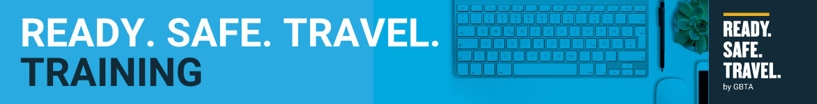

May 2021 | 4-Week Virtual Training Program
Become a Ready. Safe. Travel. Specialist.
In this 4-week, virtual, industry-wide workshop, all levels of business travel professionals unite, educate and engage buyers and suppliers alike, with curated content that delivers essential information to help transition business travel & meetings and its practices beyond the pandemic. Learning objectives include prior experiences, principles, emerging tools, government regulations, and supplier advancements that are all important to the future of business travel.
Learn how to transition business travel, meetings, and its practices beyond the pandemic. Complete the virtual training program to become a Ready. Safe. Travel. Specialist.

Participants commit to:
- Attend all 4 virtual training program sessions:
  - 3 hours every Wednesday in May -- 5, 12, 19, 26
- Complete the knowledge check quizzes after each workshop (3) within 24 hours

Ready. Safe. Travel. Specialist Benefits

- Name recognition during the final 4th celebratory keynote session and ceremony - Regionally
- A digital ‘Award of Completion’ that will be e-mailed to each recipient
- A digital badge that can be used in all e-mail & electronic signatures “Ready. Safe. Travel. Specialist”
- Ability to state after their name “Ready. Safe. Travel. Specialist”
- ROI letter to be addressed to the participant’s direct manager indicating the individual’s successful completion of the virtual training program, the key learning objectives accomplished, and the broader industry importance of the program
Registration
- Zoom dial-in details will be sent 3 hours before the event
- Registration confirmations will be sent by the close of business day, Monday - Friday Eastern.

Countdown to Convention 2021



Co

2000
Expected attendance
4 months
Away…

As we all continue to navigate the changing landscape of the pandemic, GBTA is extending the Early Bird Rate for Convention 2021: $895 for Buyers, $995 for Suppliers.

About GBTA Convention
GBTA Convention will address the recent issues in business travel with findings from travel professionals who attend the event.

Here are some additional resources to review as you consider attending:

- 2021 Exhibitors List https://gbta21.mapyourshow.com/8_0/explore/exhibitor-alphalist.cfm#/
- Convention FAQs
- Education Tracks

Corporate Travel Team Program
The Corporate Travel Team Program was introduced to help companies like yours bring more of your travel buyer team to GBTA Convention. The Corporate Travel Team Program provides value to your investment while making it easier for your organization to reach its business goals.

Here’s how it works:
Organizations will receive unlimited complimentary buyer registrations after four (4) paid registrations. Attendees must be active, direct members of GBTA to qualify.

Organizations Bringing 4+ Buyers To Convention 2021 Will Receive:
- $100 off the current registration rate for the first four (4) paid buyer member registrations along with complimentary registrations after the first four (4) paid buyer member registrations
- One (1) meeting room at the Orlando Convention Center for one (1) full day (Limited availability. First come first served.)
- Preferred housing at the Convention 2021 host hotel (Limited availability. Early

registration is strongly recommended.)
Need more reasons to attend GBTA Convention 2021 as a team?

Since the pandemic business travel has changed. Each passing day brings new, additional complexities and complications in travel and meetings management. By working together in Orlando, you’ll equip your team with a common vision of success for your program, company or organization.

Training for 2021 and beyond. Ensure your entire team is prepared for the future of business travel.

GBTA Convention 2021 educational program is designed to give you personalized, actionable takeaways for your specific travel or meetings management program.

Address Company Needs.

Our Expo floor will feature exhibitors from around the world, each offering time or cost-saving solutions or benefits designed to improve employee satisfaction or safety. Find the right tools for your organizational needs.

Ready to begin the process for your organization? Contact us at cttp@gbta.org



COVID-19 Protocols

When GBTA Convention 2021 takes place on July 17-21, nearly 2 years will have passed since the business travel community has come together in person. As an attendee, you can rest assured that as we plan for the industry’s flagship event the safety of our attendees is our #1 top priority. Find out how GBTA and the



Orange County Convention Center (OCCC) will keep you safe during GBTA Convention 2021.

OCCC has received its Global Biorisk Advisory Council® (GBAC) STAR™ accreditation on outbreak prevention, response and recovery. GBAC is a division of ISSA (International Sanitary and Supply Association) and composed of international leaders in the field of microbial-pathogenic threat analysis, mitigation, response and recovery. GBAC led the effort on the SARS outbreak and was the lead agency in the eradication of Ebola. GBAC provides training,

guidance, accreditation, crisis management assistance and leadership to government, commercial and private entities looking to mitigate, address and/or recover from biological threats in real-time.

Recognized as the gold standard of safe venues, the Orange County Convention Center (OCCC) is one of the largest venues in the nation to receive the GBAC STAR™ accreditation, view the press release.

WHAT TO DO IN ORLANDO while you’re in town for Convention 2021

For the Nature Lover…
Wekiwa Springs State Park

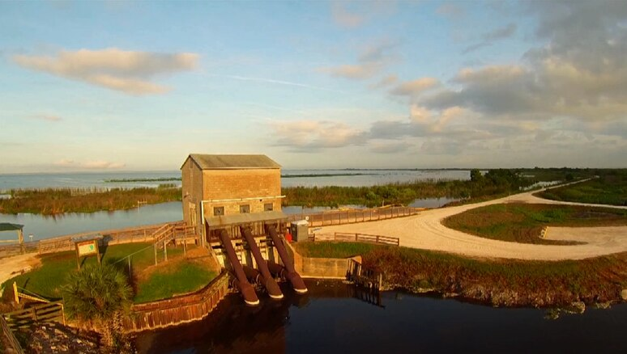
Leave the city behind and bask in the crystal clear emerald springs feeding the Wekiwa River. This unique park, just 16 miles from downtown Orlando, offers 25 miles of hiking trails, swimming and snorkeling in the refreshing 72 degree water (year round). There are numerous opportunities to encounter the animals that call the park home including river otters, raccoons, deer, fox and over 192 species of birds.

and Apopka Wildlife Drive
A true oasis for any nature lover! The restoration of former muck farms on Lake Apopka has transformed this area into a haven for wildlife. The drive is a one-way, 11-mile drive meandering through the eastern portion of the property. It begins at Lust Road and ends on Jones Avenue in Orange County, Fla. The free drive takes 1–3 hours, depending on how many visitors are enjoying the drive and how many stops you choose to make along the way.

The Lake Apopka North Shore is considered one of the most renowned birding destinations in Florida, with 369 different bird species recorded. Take in this hidden gem from the cool comfort of your own vehicle!

For the thrill seeker…
IFly Orlando
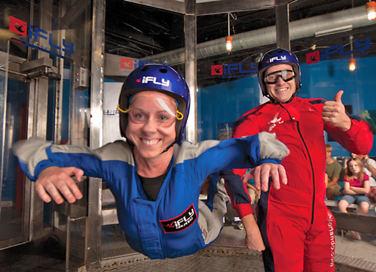
Located just off of International Drive (and near the Convention Center), IFly Orlando allows you to experience all the excitement of skydiving without having to jump out of an airplane! iFLY's vertical wind tunnel creates a wall-to-wall cushion of air on which you can safely float. There’s no parachute, no jumping and nothing attaching you to planet Earth.
For the gamer…
Escapology


Orlando's premier live escape game offers a thrilling, mind challenging experience with 7 interactive and themed game rooms. Teams of up to 8 players race against the clock to find clues, solve puzzles and escape within 60 minutes!

For the art enthusiast…
Charles Hosmer Morse Museum of American Art

The Morse Museum houses the world’s most comprehensive collection of works by Louis Comfort Tiffany (1848–1933), including the artist and designer’s jewelry, pottery, paintings, art glass, leaded-glass lamps and windows; his chapel interior from the 1893 World’s Columbian Exposition in Chicago; and art and architectural objects from his Long Island country estate, Laurelton Hall. The Museum’s holdings also include American art pottery, late 19th- and early 20th-century American paintings, graphics, and decorative art.


GBTA Awareness 5K Run/Walk

Join GBTA for the 3rd Annual GBTA Awareness 5K Run/Walk where we will be raising funds to help end human trafficking, made possible by American Airlines. Enjoy a jog (or stroll) while supporting an

important cause in the business travel industry.

Regardless of your fitness level, take part and help us end human trafficking.

According to ECPAT-USA, 1.2 million children are trafficked every year. In its third year, the GBTA Awareness 5K Run/Walk, was created to bring awareness and raise funds for this important human rights issue which also has deep implications for the business travel industry. Register now….All proceeds from this event will go directly to ECPAT-USA.

About ECPAT-USA

ECPAT-USA is the leading anti-child trafficking organization in the United States seeking to end the commercial, sexual exploitation of children through awareness, advocacy, policy, and legislation. ECPAT-USA is a member of ECPAT International, a network of organizations in more than 90 countries with one common mission: to eliminate the sexual exploitation of children around the world.


