CNFBTA
  CNFBTA
    - Monthly Newsletter
    - 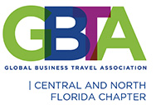
    - May 2021

coUntdown to convention 2021


May13th Virtual Lunch and Learn
The Data Story: Returning Travel Demand

Our next virtual panel will take place on May 13th. This hour long lunch and learn session will focus on the story being told by analyzing recent data trends around the return to travel. We’ll have our subject matter experts share insights on the future of travel demand, look at market research on the state of travel resumption derived from recent survey results of Meeting and Convention planners, and talk about what this means for Central Florida and our Travel industry. Bring your lunch, reserve your spot now and keep an eye out for the link to the webinar!
To register for this free webinar and to view the Bios for our speakers, please see the Calendar on the CNFBTA website https://cnfbta.org/ for MAY and click on May 13th.

Chapter Happenings

Q2 Quarterly Meeting: A Face to Face Opportunity
Ready.Safe.Travel!

After more than a year apart, we are all yearning to get together, to come face to face and to network. We are doing it! Please mark your calendars and get ready to join us on Thursday, June 17th at the AC Marriott Hotel in downtown Orlando. As we venture into a “new normal” where travel is on the rebound, this meeting will focus on what is on everyone’s mind: a return to Safe Travel. Hear from industry leaders about what they are doing to ensure a safe return to travel, their experiences over the last 16 months, and their predictions for the future of travel. Get ready for an exciting afternoon of dialogue, re-connection and updates on what is happening, and re-opening, in Central Florida. With limited in-person capacity, proper social distancing and CDC guidelines will be followed.

Registration is open! See the Calendar on the CNFBTA website https://cnfbta.org/ for JUNE and click on June 17th^{th.}

Reconnect! Rebuild! Reinvigorate!

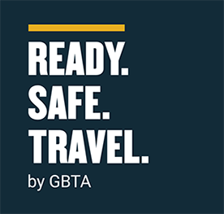

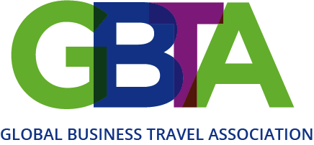

Happenings

Looking for a new opportunity in the Travel Industry? GBTA Career Center Jobs Posted Daily:
https://jobs.gbta.org/?_ga=2.112464263.209755026.1588271582-1911745970.1573143298

GBTA Statement against US Violence Towards Asian Communities
The Global Business Travel Association (GBTA), the world’s largest business travel association, condemns the recent increase in hate crimes against Chinese, Korean, Vietnamese and other Asian Americans in the United States. GBTA believes strongly in diversity, equity and inclusion. Actions that fly in the face of such principles and that rise to the level of open hatred, criminal violence and harassment are dangerous and absolutely unacceptable.
GBTA recently founded a global Diversity, Equity and Inclusion (DEI) Committee to address issues related to ensuring fair and respectful treatment for all business travelers and professionals in our industry. The committee’s mission is to increase global awareness of the many DEI-related issues facing business travel professionals – in the workplace, travelling, attending meetings, or handling travel needs.
“Travel is a force for good. During these times, the travel eco-system also needs to come together for the greater good. It should go without saying that no one should ever be targeted because of their race, gender, disability, or sexual identity,” said DEI Committee Chair J. Grant Caplan, adding: “As business travel begins to return from the dangers created by the pandemic, we must ensure safety in all contexts, including inexcusable treatment at the hands of others.”

GBTA Survey: Travel Mgrs. See Travelers Increasingly Ready to Hit the Road
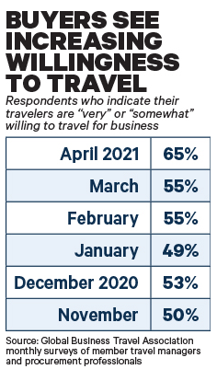

Respondents were surveyed after the U.S. Centers for Disease Control and Prevention said on April 2 that travelers fully vaccinated for Covid-19 "can travel safely within the United States" without the self-quarantine or test for the coronavirus, unless their destination requires it. About 64 percent of respondents said that updated guidance made them personally "somewhat" or "much more comfortable" about the possibility of business travel, and 52 percent projected the move would have "some" or "major" influence on their companies' timeline to restart travel. About 15 percent indicated the CDC's move would have "no influence at all."

GBTA Welcomes The European Parliament’s Position

to introduce a unified, digital EU COVID-19 certificate negating any additional restrictions for travellers
Brussels (April 29, 2021) – The Global Business Travel Association (GBTA), the world’s largest business travel association, welcomes the outcome of yesterday’s vote by the European Parliament and calls upon EU Governments to embrace the push for harmonised rules and the gradual lifting of unilateral travel restrictions during upcoming negotiations on a final text.
The Digital Green Certificate will verify that a person has been vaccinated against COVID-19 using a vaccine authorised in the EU by the European Medicines Agency (EMA), has recovered from the virus, or has a negative test result. The European Parliament voted in favour of preventing holders of the digital certificate to be subject to additional travel restrictions, such as quarantine, self-isolation or testing, thus restoring the free movement of business travellers across Members States. The European Parliament also agreed to avoid discriminations on economic grounds or on vaccine coverage, asking EU countries to ensure universal, accessible, timely and free of charge testing.
“More than a year after countries across Europe and the world decided to close borders and restrict travel to contain the spread of COVID-19, improved testing protocols and vaccination uptake are providing hope that safe travel can resume shortly. The announcement today provides some confidence to companies looking to resume business travel, which in turn will provide a much-needed economic boost to the travel, hospitality, and events sectors across European countries” said Suzanne Neufang, CEO – GBTA.
“We are delighted that Members of the European Parliament agree that holders of the EU COVID-19 digital certificate should not be subject to additional or adhoc travel restrictions and we welcome their demand for tests to be accessible, timely and free of charge. These are positive steps towards the resumption of business travel, and we encourage EU institutions to align to ensure the certificate becomes operational swiftly.”


GBTA Honorary Membership
GBTA will provide business travel professionals who have been displaced due to the impact of coronavirus and the global pandemic a GBTA Honorary Membership. This membership will be valid until August 1, 2021 or until finding employment. GBTA is committed to helping the business travel community stay connected during this challenging time.
https://form.jotform.com/201064057431040
Countdown to Convention 2021: dates change to November 17-19



Co

2000
Expected attendance
6 months
Away…

Corporate Travel Team Program
The Corporate Travel Team Program was introduced to help companies like yours bring more of your travel buyer team to GBTA Convention. The Corporate Travel Team Program provides value to your investment while making it easier for your organization to reach its business goals.

Here’s how it works:

Organizations will receive unlimited complimentary buyer registrations after four (4) paid registrations. Attendees must be active, direct members of GBTA to qualify.

Organizations Bringing 4+ Buyers To Convention 2021 Will Receive:
- $100 off the current registration rate for the first four (4) paid buyer member registrations along with complimentary registrations after the first four (4) paid buyer member registrations
- One (1) meeting room at the Orlando Convention Center for one (1) full day (Limited availability. First come first served.)
- Preferred housing at the Convention 2021 host hotel (Limited availability. Early registration is strongly recommended.)
Need more reasons to attend GBTA Convention 2021 as a team?

Since the pandemic business travel has changed. Each passing day brings new, additional complexities and complications in travel and meetings management. By working together in Orlando, you’ll equip your team with a common vision of success for your program, company or organization.

Training for 2021 and beyond. Ensure your entire team is prepared for the future of business travel.

GBTA Convention 2021 educational program is designed to give you personalized, actionable takeaways for your specific travel or meetings management program

